Positivity People Chains

Time: 30 minutes

Materials:
A4 paper
Scissors
Colouring pens or pencils
Glue or a stapler

Part One – Before the class

- Cut a strip of paper for each pupil in the class

Part Two – 20 minutes

- Give each pupil a strip of paper, scissors and colouring pens or pencils.
- Next ask pupils to complete steps 1-5 in the worksheet.

Part Three – 10 minutes
- Once all the people chains are connected ask the pupils to hold the giant chain and see how big of a circle they can make together.
- Finally, ask pupils what words they put on their chains and why.

We would love to see pictures of your pupils Positivity People Chains! Tweet them using #PupilVoiceWeek and @tootootofficial!

Positivity People Chain - Worksheet

- Concertina fold a strip of paper.
The number of folds you make will be the number of people in your chain.
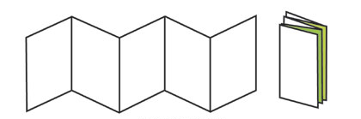

- Draw a person on the top of your folded paper.
Make sure the arms go off the edges of the paper, so when you open up, they will be holding hands.
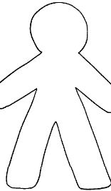

- Carefully cut out the person, but make sure you leave the edges of the arms intact where they touch the edge of the paper.
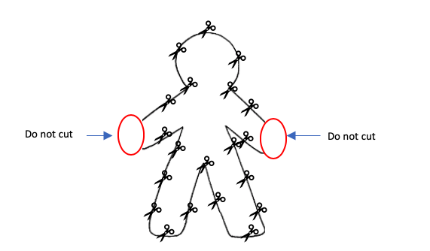

- Open up your chain and decorate with words of positivity and kindness.

- Finally connect your chain to your classmate’s chain using glue or a stapler.

